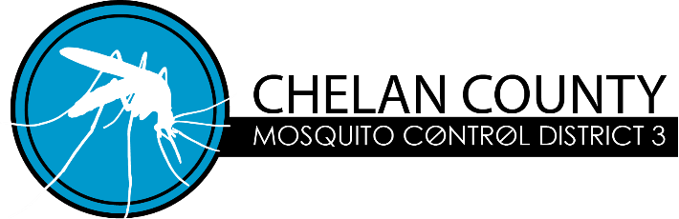
14193 Chiwawa Loop Rd. #8
Leavenworth, WA 98826
www.ccmcd3.us

AGENDA
Meeting 4:00pm Monday August 18, 2025

Call to Order
Approval of Minutes from August 19th, 2024 annual meeting
Review and discuss the Washington State Annual Report
Review and discuss the Aquatic Permit Treatment Annual Report
Review Revenue, Expenditures & Current Financial Position
Review the proposed 2025 Operating Budget
Review and approve the following Resolutions:
Resolution 2025-1 “Establish 2026 operating budget”
Resolution 2025-2 “Establish 2026 Benefit Assessment Fee”
Resolution 2025-3 “Approve 2025 Voucher Expenditures”
Resolution 2025-3-A “Approve 2025 Voucher Expenditures”
Resolution 2025-4 “Reappoint Expiring Board Members”
Resolution 2025-5 “Election and Appointment of Officers”
Resolution 2025-6 “Authorized Signatures for Chelan County Auditor”
Resolution 2025-7 “2026 Meeting Schedule”

New Business

